After downloading the MOU, please complete the following instructions:

- Update the Submitting Entity section to your entity name and address
  - E.g.,
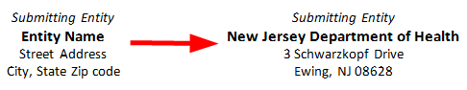

- Have an authorized signatory sign SECTION 5: SIGNATURES

- Save the MOU as a PDF

- Email the signed MOU to RSTCLIRsupport@mayo.edu with the subject of “SIGNED MOU“

- The CLIR support team will complete the following steps:
  - Rename the MOU to the corresponding location name within CLIR
    - E.g., “USA-NJ MOU” for New Jersey Department of Health
  - Have a Mayo official designated by our legal department sign the MOU within 5 business days
  - Register a copy of the signed MOU with Mayo’s legal department and store a readily accessible copy with other CLIR documentation
  - Reply to all recipients of the “SIGNED MOU“ email with the new subject of “EXECUTED MOU“, including the MOU signed by both entities

*NOTE: While we are not accepting modifications at this time, if you have future suggested changes, please send email RSTCLIRsupport@mayo.edu with the subject of “SUGGESTED MOU REVISIONS“.

